**Creating Events and Exhibitions in Wordpress**

1. Select “Events” and click on “Add New”

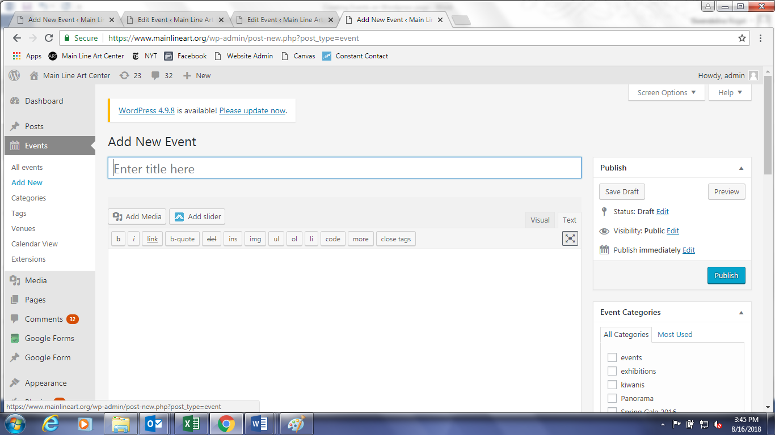

1. Type in the name of the event in text box under “add new event,” and check the “events” or “exhibitions” box in the Event Categories on the right side.

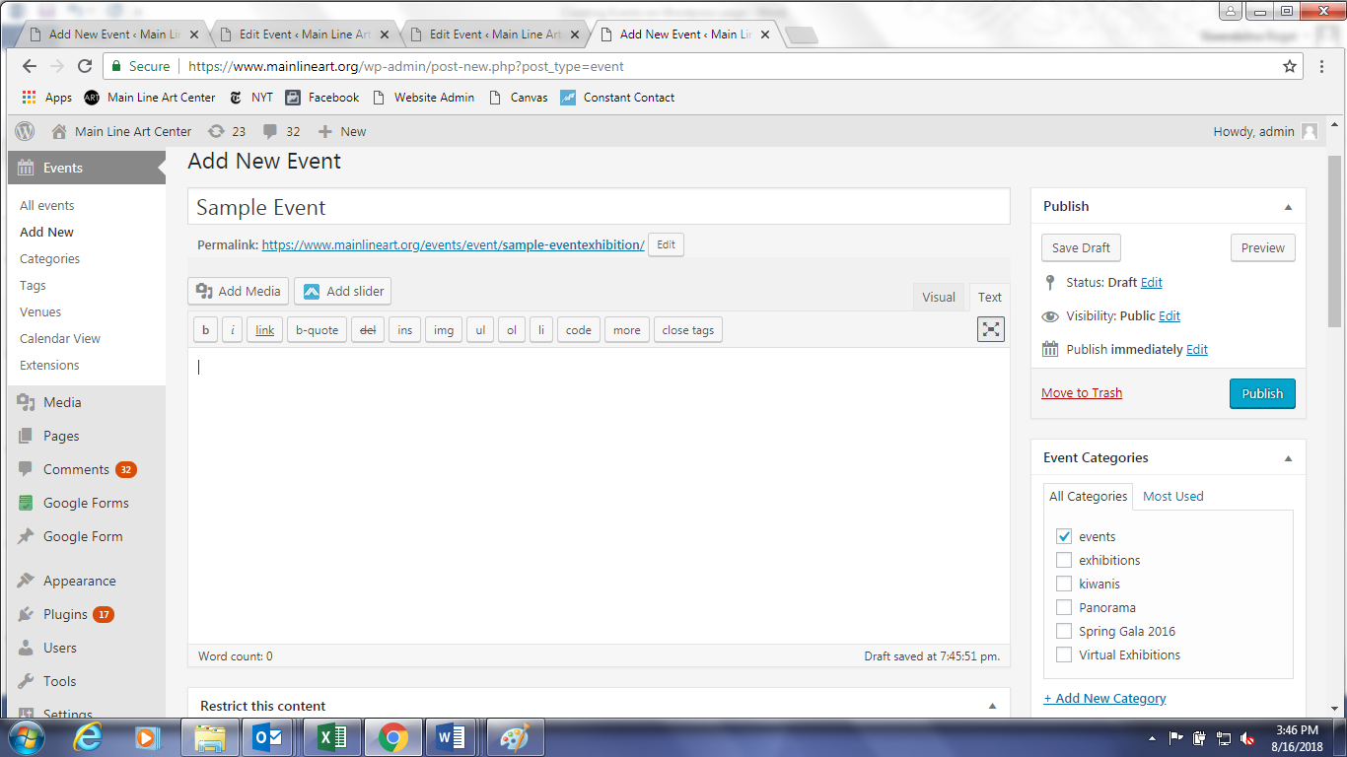

1. Scroll down and select the event start date/time & end date/time. When selecting time/date for exhibitions, be sure to check the box “all day” if it lasts for more than one day. You can choose to specify venue if it is different from the Art Center (which is the automatic default setting.)

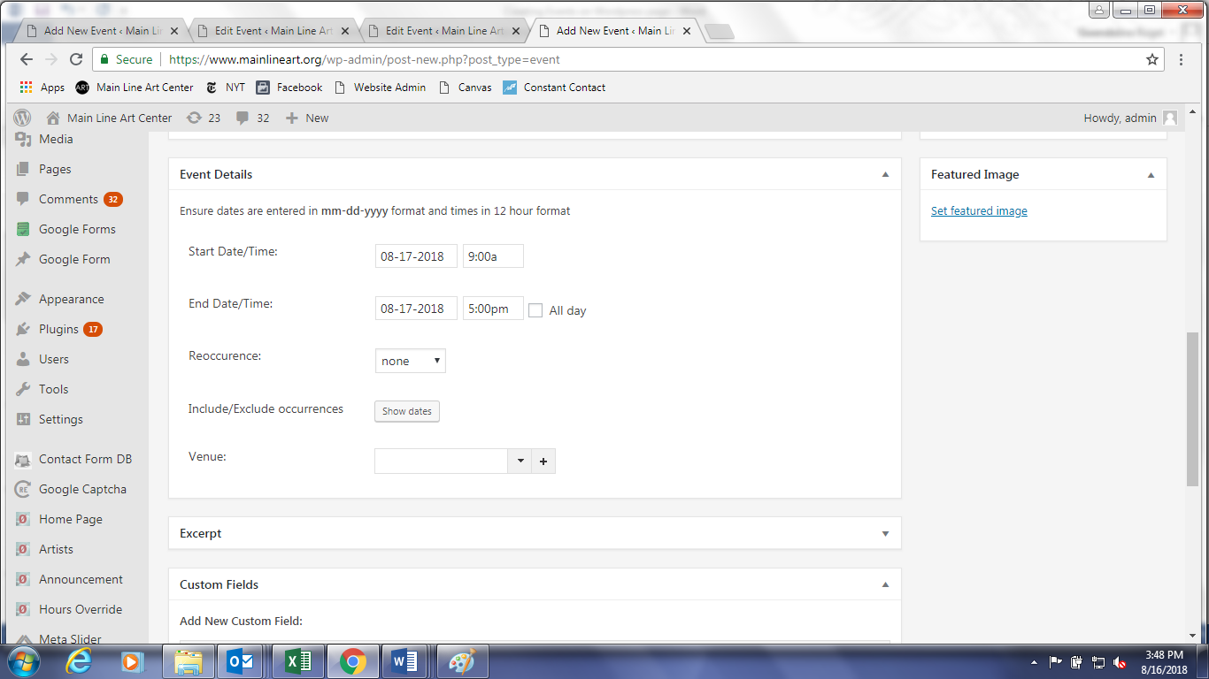

1. 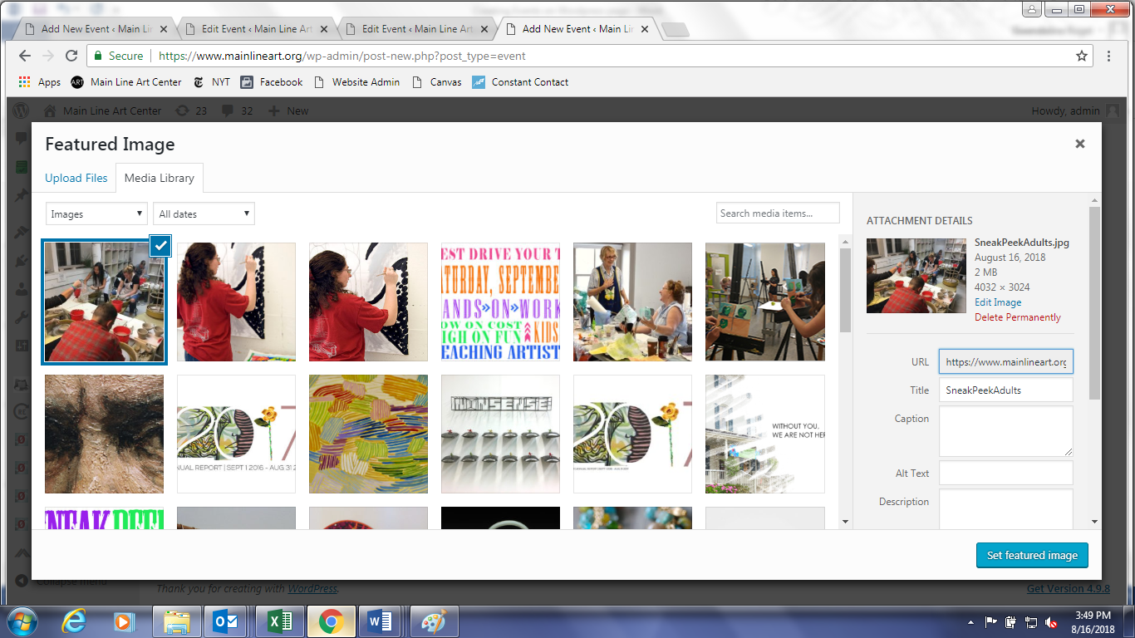On the right side where it says Featured Image, click on “Select Featured Image.” The Media Library will pop up. Click on Upload Files, and add in the image you’d like to use from the shared drive. Then click on Set Featured Image.
2. Open up a new tab on your browser, and select a past or upcoming event/exhibition on the Art Center website. For this example, we’ll choose the upcoming Holiday Craft Market.
3. Under this new tab with the Holiday Craft Market event page, click on “Edit Event” at the top of the screen.

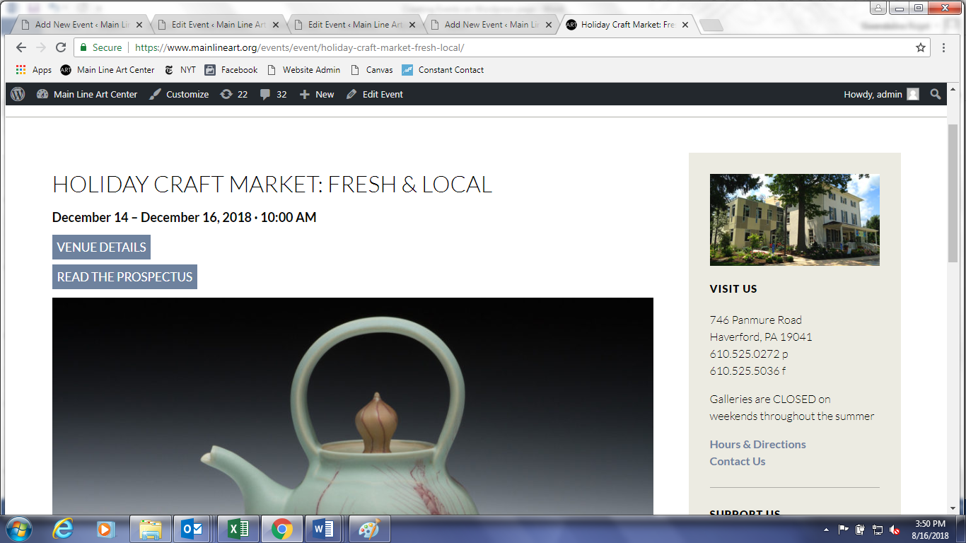

1. Copy and paste the coding in the body of the text from the Holiday Craft Market page into the body of the new event page you are creating
2. The highlighted text you see below should be deleted. Here is where you will input the URL link to the new PDF of your choice. In order to add a new PDF, click on “Add Media,” “Upload Files,” and select the PDF from the shared drive.

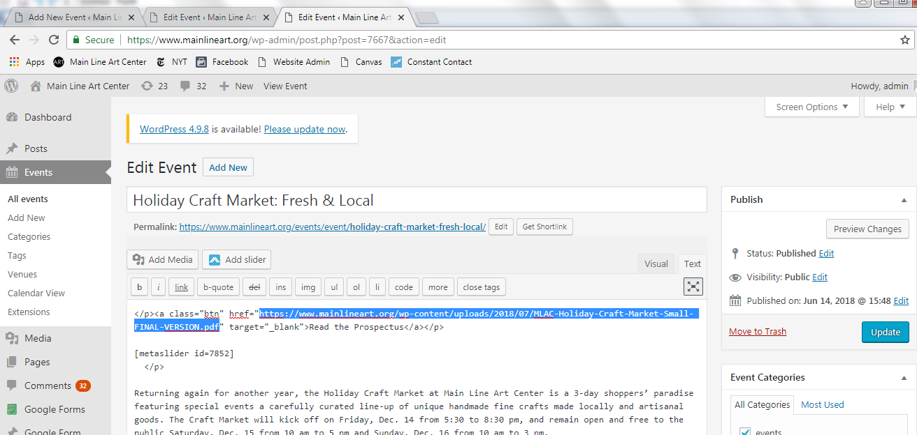

1. 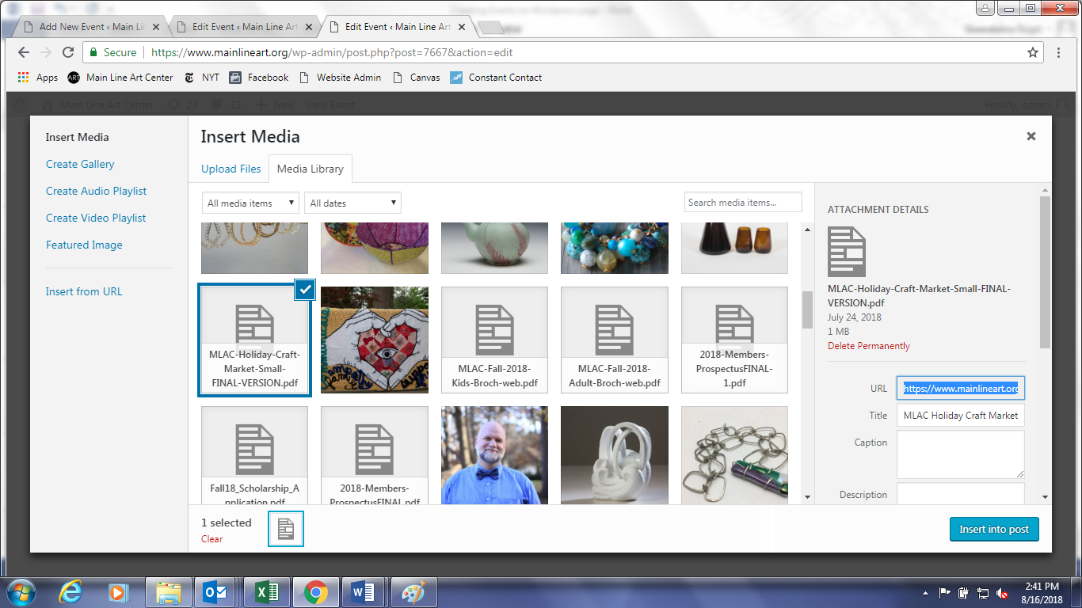Copy and paste the URL link of the new PDF
2. 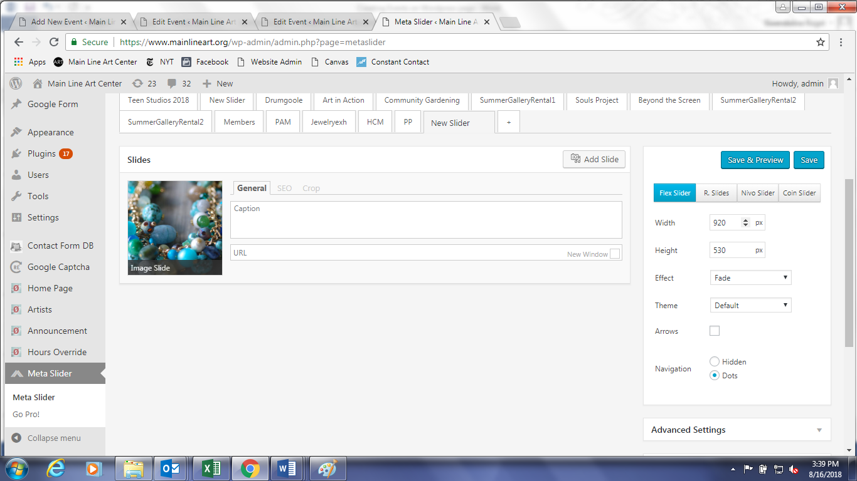You will notice there is a metaslider link. This refers to the slideshow that was created on the page. To create a slideshow, open up a new tab on your browser and click on Meta Slider on the Dashboard
3. Click Add slides, upload images, and add in caption info under General. You don’t need to put in anything in where it says URL. Click save.
4. Scroll down where it says Usage and shortcode, and copy and paste the new metaslider shortcode into the text box of your event page.

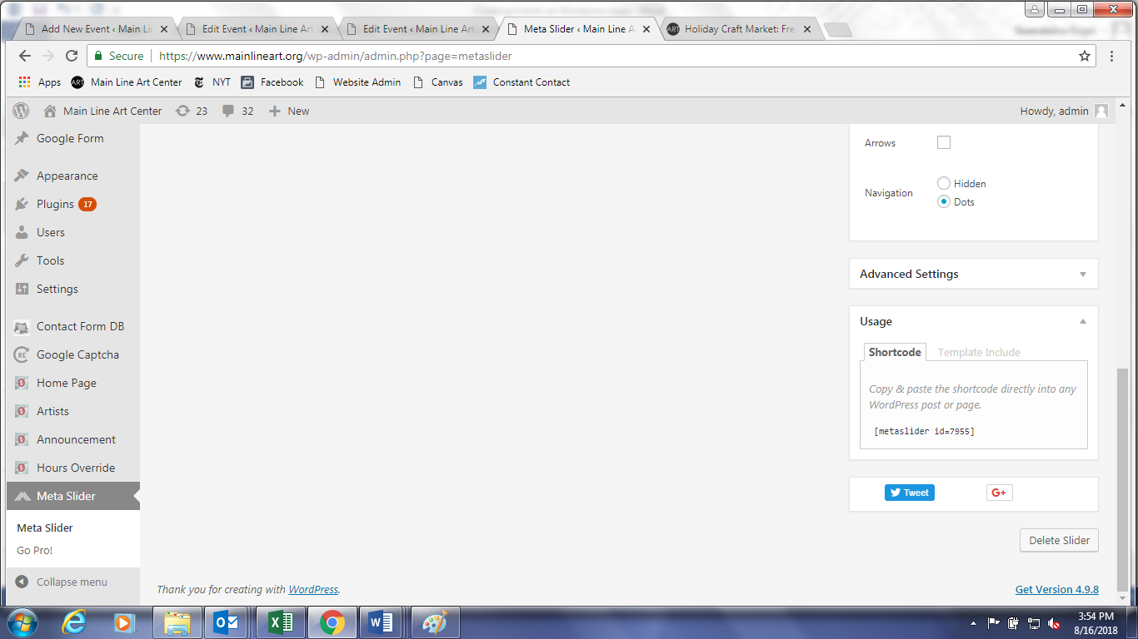

1. Go back to your event/exhibition page, delete and rewrite new event/exhibition description as needed.
2. Click Preview Changes to check how the new event/exhibition page looks first (it will open to a new tab), and then select Update.