**MLartsl.tif**  
  
FOR IMMEDIATE RELEASE  
CONTACT: Lisa Getz, Communications Director|610.525.0272 x125|[lgetz@mainlineart.org](mailto:lgetz@mainlineart.org)

746 Panmure Road   
Haverford, PA  19041  
610.525.0272  
www.mainlineart.org

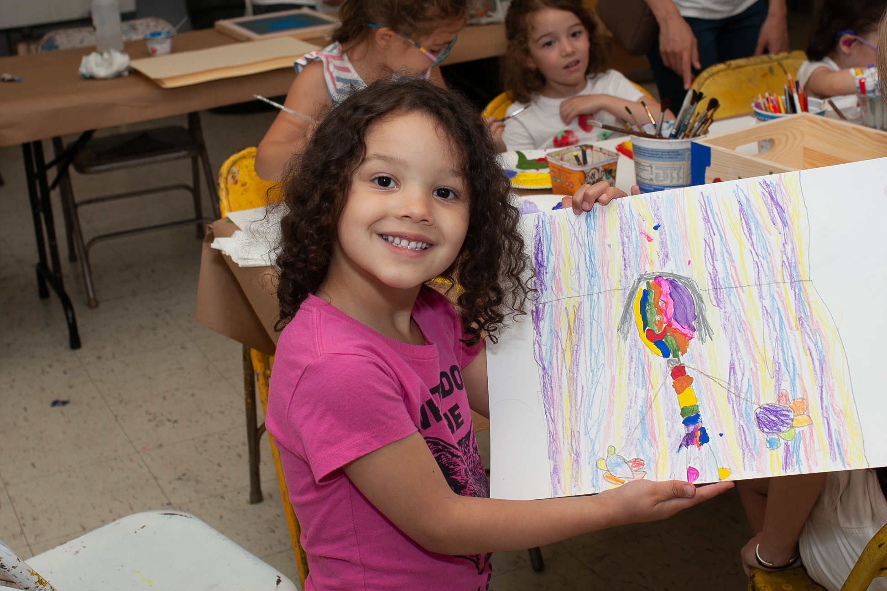

**Main Line Art Center Announces $20,000 Challenge Grant from   
the Samuel P. Mandell Foundation**

HAVERFORD, PA (August 21, 2018) — Main Line Art Center in Haverford is excited to announce a $20,000 Challenge Grant from the Samuel P. Mandell Foundation to help support the Center’s annual fundraising campaign. Now through August 31, 2018, any tax-deductible donation made to the Center will be matched, dollar for dollar up to $20,000. Donations can be made online at [www.mainlineart.org](http://www.mainlineart.org), by phone at 610.525.0272, or in person at 746 Panmure Road in Haverford. Thanks to the kindness of our community, we are more than halfway to our goal of $119,000.  
  
As a non-profit organization, Main Line Art Center relies on the generosity of foundations, individuals, and business partners to run its programs, which last year reached over 36,000 people through classes, exhibitions, lectures, and special events held at the Center, and 82,500 people in the Greater Philadelphia area through partnerships and programs in the community.   
  
“The consistent support of the Samuel P. Mandell Foundation over many years is an invaluable gift to the Center,” said Thomas Scurto-Davis, Executive Director of the Main Line Art Center. “The foundation’s ongoing generosity is a remarkable demonstration of the depth of their commitment to the arts and to building strong communities in which individual and collective expression serve to remind us of our shared humanity. This effect is further amplified by designating the gift as challenge grant, which acts as a lever, motivating broader support from all facets of the community. While the Center is the grateful recipient, the community is its enduring beneficiary.”

**Main Line Art Center** is the community’s home to discover, create, and experience visual art. The mission of Main Line Art Center is to inspire and engage people of all ages, abilities, and economic means in visual art through education, exhibitions, and experiences. Main Line Art Center’s educational offerings span from traditional to contemporary, and are all held to the highest level of excellence. Committed to increasing the visibility and accessibility of art, the Center also presents innovative exhibitions and events in the community. In 2015, Main Line Art Center received the Commitment to Cultural Access Award from Art-Reach for the Center’s Accessible Art Programs for children and adults with disabilities, now in their 56th year. Additionally, the Center grants over $12,000 in need-based scholarships annually.  
  
Main Line Art Center is located at 746 Panmure Road in Haverford, PA, just off of Lancaster Avenue. The Art Center is easily accessible from public transportation and offers abundant free parking. For more information or to make a donation, please visit [www.mainlineart.org](http://www.mainlineart.org) or call 610.525.0272.

# # #

Image credit: © Howard Pitkow