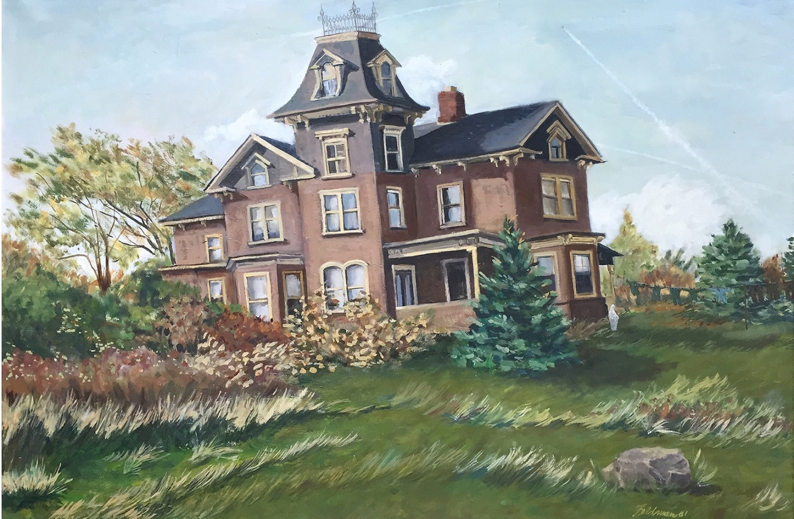

**Marge Feldman**

***Rooted***

1974

$1,000

610-660-5082 ____________________ Check IN ____________________ Check OUT

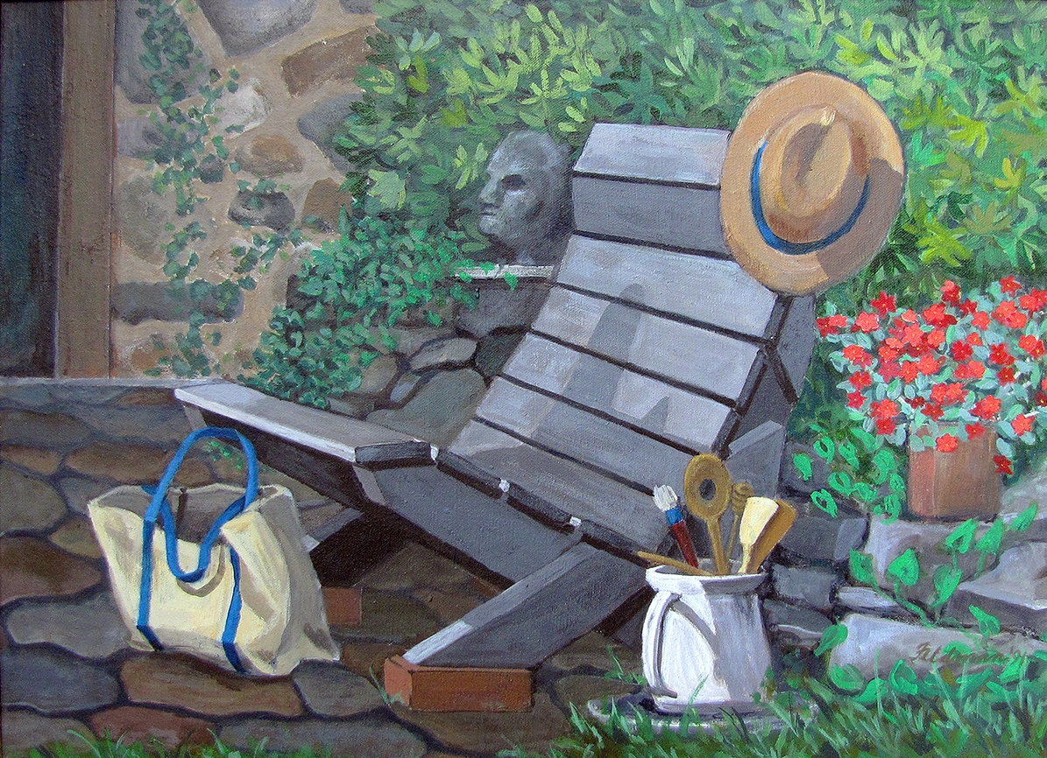

**Marge Feldman**

***Impatiens***

1991

$500

610-660-5082 ____________________ Check IN ____________________ Check OUT

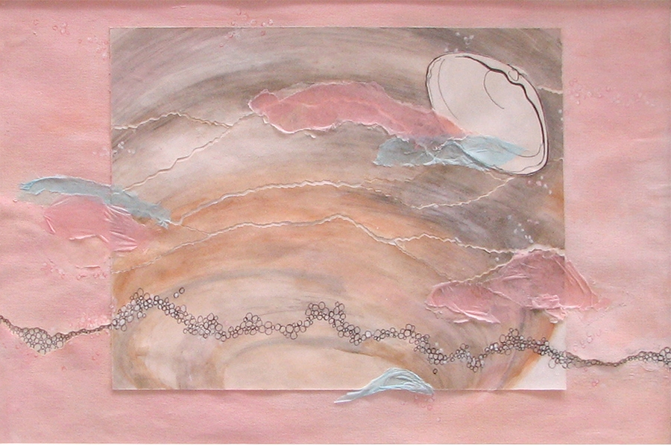

**Marge Feldman**

***Seashell***

Mixed Media Collage

1991

$250

610-660-5082 ____________________ Check IN ____________________ Check OUT

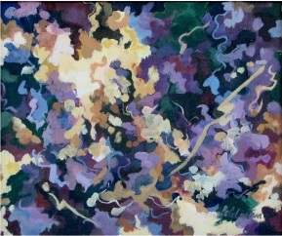

**Marge Feldman**

***Sunlit Pond***

1996

$250

610-660-5082 ____________________ Check IN ____________________ Check OUT



**Marge Feldman**

***Black Velvet***

1996

$350

610-660-5082 ____________________ Check IN ____________________ Check OUT

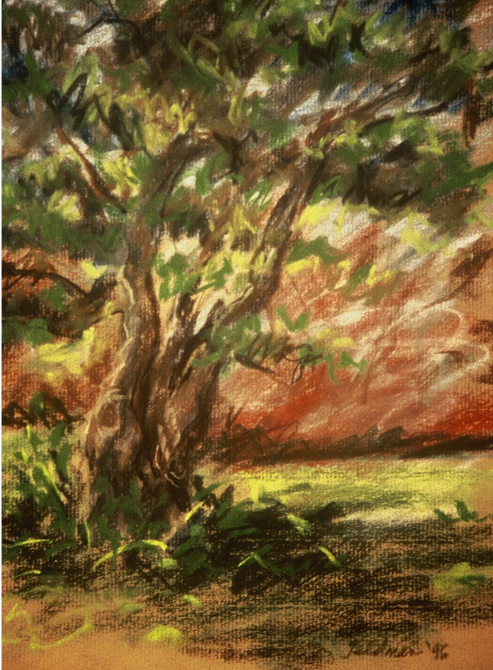

**Marge Feldman**

***Gnarly***

12” x 9”

1996

$150

610-660-5082 ____________________ Check IN ____________________ Check OUT

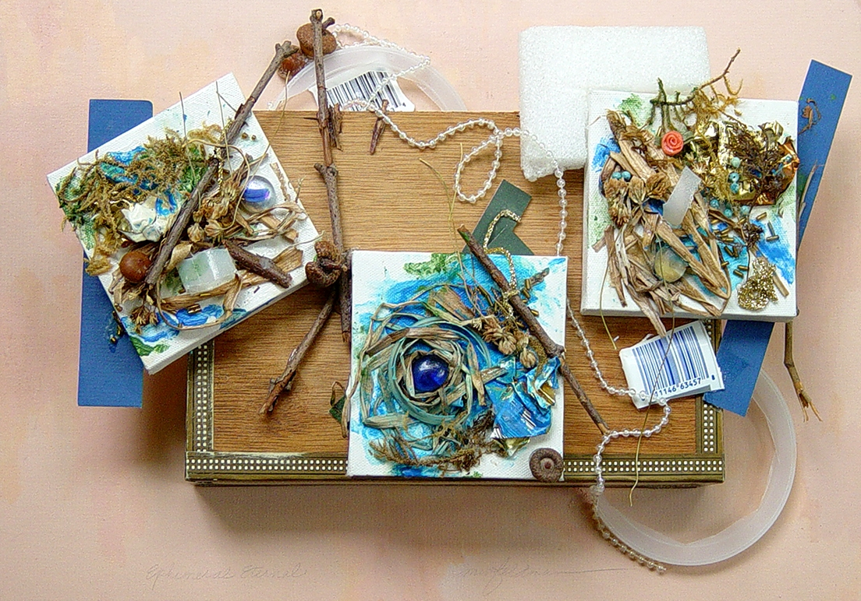

**Marge Feldman**

***Ephemeral Eternal***

Assemblage

12” x 18” x 4”

2004

$400

610-660-5082 ____________________ Check IN ____________________ Check OUT

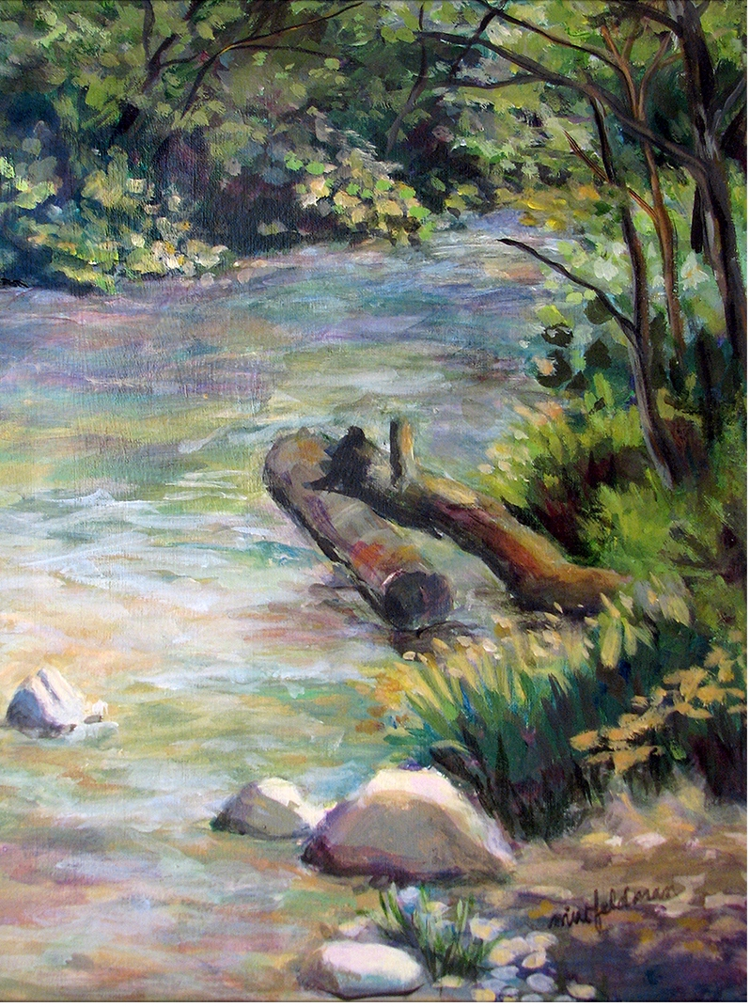

**Marge Feldman**

***Summer Stream***

12” x 16”

2004

$250

610-660-5082 ____________________ Check IN ____________________ Check OUT