**MLartsl.tif**  
  
FOR IMMEDIATE RELEASE  
CONTACT: Rachel Ammon, Communications Director|610.525.0272 x125|[rammon@mainlineart.org](mailto:rammon@mainlineart.org)

746 Panmure Road   
Haverford, PA  19041  
610.525.0272  
www.mainlineart.org

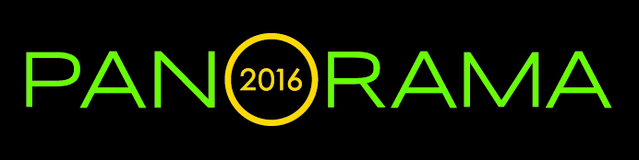

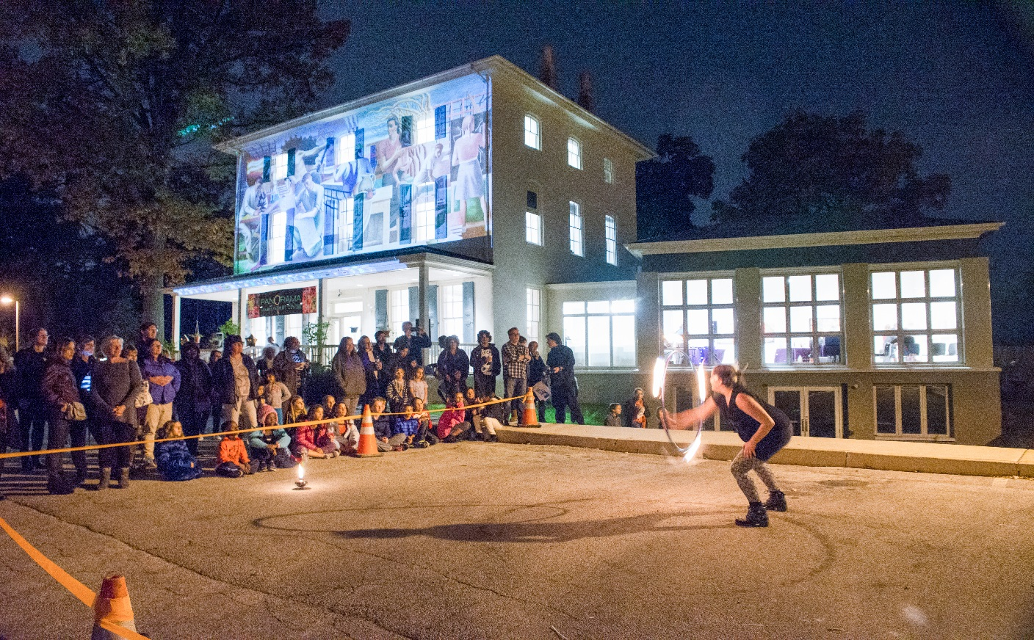

**Multimedia Spectacle Planned for 2016 *Panorama* Festival at   
Main Line Art Center in Haverford****Saturday, October 22, 5 to 9 pm***Fire Spinning Special Performance: 7-7:30 pm  
Interactive, Multimedia Performance by Digital Artist in Residence Leo Hylan: 7:30 pm  
Darkroom Installation with Matt Giel: 6-8 pm  
DJ, Food Trucks, Demos, Interactive Art: 5-9 pm*

HAVERFORD, PA (October 4, 2016) — Digital and hands-on are set to collide on Saturday, October 22 from 5 to 9 pm at Main Line Art Center in Haverford for this year’s *Panorama* Festival. From fire spinners, stilt walkers, food trucks, and multimedia live art performances outside, to interactive digital demos and stunning contemporary artwork inside, Main Line Art Center’s signature event promises to be a delight for all of the senses.   
  
The free Festival anchors the Art Center’s second presentation of *Panorama: Image-Based Art in the 21st Century*, which boasts 50+ events from September to November presented by the Art Center and its 40+ partners across Greater Philadelphia celebrating photography and digital media in contemporary art. *Panorama* 2016 is supported in part by an award from the National Endowment for the Arts.  
  
The party won’t be hard to miss! Firespinners and stilt walkers from [7textures](http://www.7textures.com/) will perform from 5:30-7:30 pm, and will put on a special presentation from 7 to 7:30 pm. Main Line Art Center’s historical white house will become a canvas as 2016 Digital Artist in Residence [Leo Hylan](http://hylantown.com/) lights up the night with site-specific, interactive multimedia performances projected on the front and side of the building. Festival attendees can grab a bite from food trucks Chef Johnny Bravo's Surf n Turf and Short Order Mobile Cuisine as they groove to the sounds of DJ The Architech.

Once inside, Festival-goers can gather inspiration from *Panorama* feature exhibition [*Enlightened Earth*](https://www.mainlineart.org/events/event/panorama-2016-feature-exhibition/). On view through November 5, *Enlightened Earth* explores nature and our complex relationship to its past, present, and future with works by [Julianna Foster](http://juliannafoster.com/home.html) (Philadelphia, PA), [Nick Pedersen](https://nick-pedersen.com/) (Burlington, NJ) and [Mark Dorf](http://mdorf.com/) (New York), who was recently included on Art Zealous’ list of *30 Under 30ish*. Their work leads us down a path of multi-layered, multi-media discovery through storytelling, scientific research, and fantastical landscapes.

The party doesn’t stop at the gallery! Festival attendees can make their way from studio to studio to channel their own creativity through hands-on projects melding new technology with traditional mediums. Activities include image transfers onto wood to create coasters or ornaments, silkscreen prints and t-shirts (available for purchase), and collaborative stop-animation productions. In the Art Center’s traditional black and white dark room, artist [Matt Giel](http://mattgiel.com/) will present an installation featuring his photography from 6 to 8 pm.  
  
During the Festival, and through November 5, artists of all ages are encouraged to create and upload digital photos, animation, or short videos for the *Panorama* virtual exhibition, *Earth Works*. Work can be made at one of the Art Center’s Green Partners, gardens, arboretums, and green spaces in Greater Philadelphia, or at a location of their choosing. The exhibition will go live on mainlineart.org in January. Cash awards will be given to one adult artist and one youth artist selected as Best in Show.

Prior to the Festival on October 22 from 1 to 4 pm, Main Line Art Center is offering [Portfolio Reviews](https://www.mainlineart.org/events/event/panorama-portfolio-reviews/) with members of the Center’s Artistic Advisory Board and internationally-exhibited artist Mark Dorf, featured in *Enlightened Earth*. Artists will gain valuable feedback on their work and make connections with experts in the field as they participate in one-on-one artwork reviews. Space is limited. To register ($95) visit [www.mainlineart.org](http://public.mainlineart.org/public/AdultPreview.faces?wrkid=9613) or 610.525.0272.  
  
*Panorama* continues through November 5, and is supported by Business Partners [Wilkie Lexus](http://www.wilkielexus.com/), [Main Line Today](http://www.mainlinetoday.com/), [Barefoot Wine & Bubbly](http://barefootwine.com/), [Merion Art & Repro](http://www.merionartblog.com/), [PECO](https://www.peco.com/Pages/default.aspx), [Pennsylvania Council on the Arts](http://www.arts.pa.gov/Pages/default.aspx), [National Endowment for the Arts](https://www.arts.gov/), th0e [Philadelphia Inquirer](http://www.philly.com/), [DesignPhiladelphia](http://2016.designphiladelphia.org/), and [Stage Trip Productions](http://stagetrip.net/). For a full list of *Panorama* events, including those presented by Main Line Art Center’s 40+ *Panorama* Creative Partners, visit [www.mainlineart.org/panorama2016](https://www.mainlineart.org/events/event/panorama-2016-image-based-art-in-the-21st-century/) to download the Digital Guide.   
  
**Main Line Art Center** is the community’s home to discover, create, and experience visual art. The mission of Main Line Art Center is to inspire and engage people of all ages, abilities, and economic means in visual art through education, exhibitions, and experiences. Committed to increasing the visibility and accessibility of art, the Art Center presents innovative exhibitions and events in the community, including *Panorama: Image-Based Art in the 21st Century*, a Greater Philadelphia-wide celebration of the photographic image and digital media. Main Line Art Center’s educational offerings for all ages, abilities, and economic means span from traditional to contemporary, and are all held to the highest level of excellence.  In 2015, Main Line Art Center received the Commitment to Cultural Access Award from Art-Reach for the Center’s Accessible Art Programs for children and adults with disabilities, now in their 52nd year. Additionally, the Art Center grants over $12,000 in need-based scholarships annually. Last year, Main Line Art Center engaged 21,000 people through classes, exhibitions, and Summer Art Camp, and touched the lives of over 78,000 through Exhibitions in the Community and festivals across the Philadelphia area.  
  
Main Line Art Center is located at 746 Panmure Road in Haverford, PA, just off of Lancaster Avenue. The Art Center is easily accessible from public transportation and offers abundant free parking. For more information about the Panorama Festival, visit [www.mainlineart.org/panorama2016](http://www.mainlineart.org/panorama2016) or call 610.525.0272.

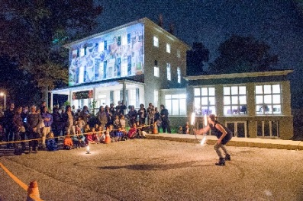  
© Leah Macdonald 2015  
  
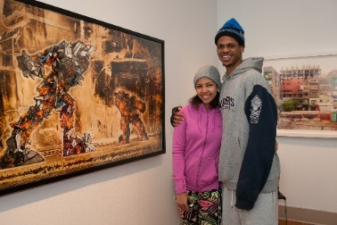  
© Howard Pitkow 2015  
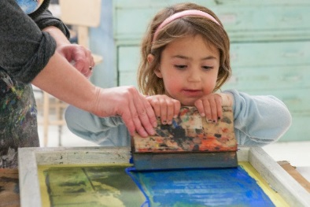  
© Howard Pitkow 2015