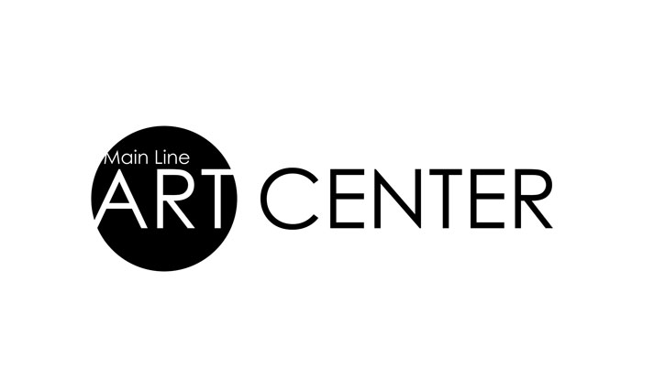

Main Line Art Center *classes at* The Haverford SchoolStudent Reference

*Thank you for choosing to spend part of your summer with us!*

**DIRECTIONS to The Haverford School from Main Line Art Center:**

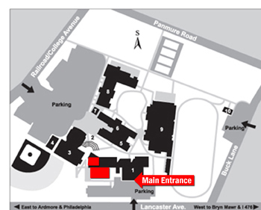

**Start at: Main Line Art Center**  
746 Panmure Road, Haverford PA 19041

* Turn RIGHT onto Old Buck Lane.
* Turn LEFT onto Buck Lane.
* Turn RIGHT onto Lancaster Avenue.
* Turn RIGHT into school's parking lot (Booth Lane).
* **From parking lot, walk to the LEFT SIDE ENTRANCE**

**of the building (not the main central doors).**

* From the left side entrance, enter directly into the

Double doors to Art Department. There will be signs.

**(Instructor will unlock the doors).**

**End at: The Haverford School**450 Lancaster Ave., Haverford, PA 19041

**Left Side Entrance**

**PARKING:**Parking is available at the front of Wilson Hall in the   
GREEN LOT on Lancaster Avenue.   
*Alternate parking is available in the RED LOT off of Railroad Avenue.*

**Important Info and FAQ:**

* When facing the front of The Haverford School, students should enter the **left side** of the building.
* **If you arrive late and the building is locked**:
* Go around to the left side of the building and knock on the Art Studio entrance.
* If you are still unable to get in, there is a call box at the Main entrance where you can dial Public Safety.

***Will there be studio equipment available?*** Yes. Most of the equipment that is usually provided by MLAC will be available at the Haverford School (easels, lights, etc, depending on what was requested by the teacher for class use), or similar substitutions will be made. Please contact the Art Center staff at least a week in advance if you need any special accommodations.

***What will students have access to?***  Students will have access to the art studios, equipment, and nearby bathrooms. Sinks are located in the studios. Students are asked to limit themselves to this area of the building.

*We appreciate your support and keeping mindful that this is a loaned space that we are using. Please be sure to clean up when you are done with class and take belongings home. We want to make sure the studios are left as we found them so The Haverford School students can enjoy their facilities when they return in September!*

**Don't forget that you can access supply lists by visiting your class listing online.**

**Please call us at 610.525.0272 ext. 110 or email info@mainlineart.org with any questions**.