**MLartsl.tif**  
  
FOR IMMEDIATE RELEASE  
CONTACT: Rachel Ammon, Communications Dir. | 610.525.0272 x125 | rammon@mainlineart.org

746 Panmure Road   
Haverford, PA  19041  
610.525.0272  
www.mainlineart.org

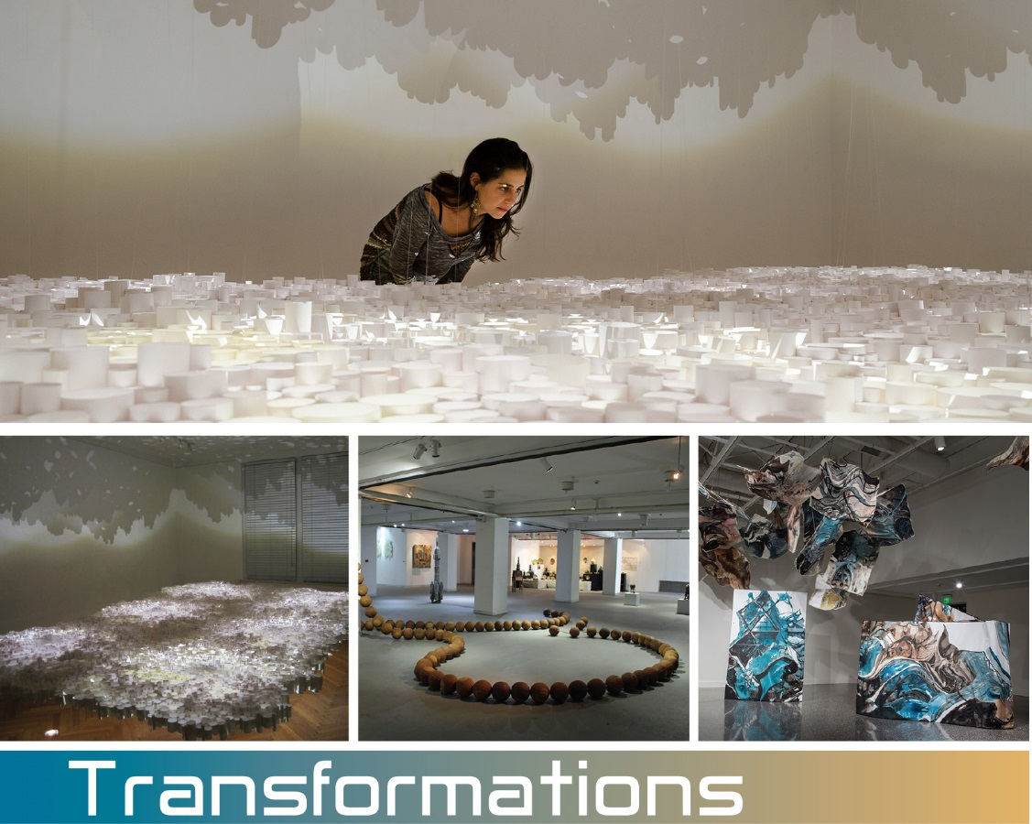

***Transformations* Coming to Main Line Art Center**

**2016 Meyer Family Award for Contemporary Art Recipients:**Matthew Courtney (Philadelphia), Sun Young Kang (Bryn Mawr), Zahra Nazari (New York)

**Curated by: Amie Potsic, Executive Director of Main Line Art Center**

**March 7 - April 17, 2016**

**Artist Talks & Opening Reception: Friday, March 11**

Artist Talks: 5:30-6:30 pm | Reception: 6:30-8:30 pm

**Jazz Concert with Nancy Weiss: Monday, March 14, 7-8:30 pm**

**Artist Workshops:**[**Throwing Forms, Building Sculpture**](http://public.mainlineart.org/public/AdultPreview.faces?wrkid=9373) | Matthew Courtney | Tues., April 5, 1-6 pm  
[**Persian Reverse Glass Painting**](http://public.mainlineart.org/public/AdultPreview.faces?wrkid=9374) | Zahra Nazari | Sun., April 10, 1-4 pm   
[**Book-Making: 1 Sheet of Paper, 5 Ways**](http://public.mainlineart.org/public/AdultPreview.faces?wrkid=9372) | Sun Young Kang | Sat. & Sun., April 16-17,

9:30 am- 12:30 pm

HAVERFORD, PA (February 16, 2016)— Main Line Art Center in Haverford is proud to announce Matthew Courtney (Philadelphia), Sun Young Kang (Bryn Mawr; 2015 Finalist), and Zahra Nazari (New York) as the 2016 recipients of the Meyer Family Award for Contemporary Art. Selected by Members of Main Line Art Center’s Board of Artistic Advisors and Executive Director through a highly competitive application process, Courtney, Kang, and Nazari will be featured in *Transformations*, the 12th Annual Betsy Meyer Memorial Exhibition, on view at Main Line Art Center March 7 to April 17.

Masters of their primary mediums and inspired by cultural specificity, each artist expands their artistic practice to embrace installation with works that fully engage the audience in constructed objects, the spaces they inhabit, and the concepts they conjure. Through painting, ceramic sculpture, and paper arts, the artists transform, not only their own materials, but the galleries themselves into unexpected environments that dance between the evident and the ethereal.  
  
Now in its twelfth year, Main Line Art Center is proud to present an annual exhibition in memory of Teaching Artist Betsy Meyer featuring the work of forward-thinking artists who are pushing boundaries within their artistic practice. As an artist, Betsy exemplified what is most exciting about engaging with the artwork of living artists: watching them experiment with their media and tackling complicated and tough subjects. As a teacher, she encouraged her students to follow her example and expand their practice into new frontiers. And finally, as a member of the board and exhibition committee, she assured that the Art Center was there for the artistic community of Philadelphia.

The Meyer Family Award for Contemporary Art, presented by Main Line Art Center in conjunction with the Betsy Meyer Memorial Exhibition, consists of an award of $1000 and a solo exhibition to each selected artist. This award and associated exhibition program is an effort to support the talented contemporary artists in the region, to honor deserving artists in the field, and to encourage excellence and experimentation in artistic practice, presentation, and community involvement.

Approximately three artists are awarded annually. The 2015 recipients of the Meyer Family Award for Contemporary Art were Seunghwui Koo (New York), Tasha Lewis (New York), and Kate Stewart (Philadelphia), whose work was featured in[*Tweak of Nature*](http://www.mainlineart.org/events/event/tweak-of-nature-11th-annual-betsy-meyer-memorial-exhibition/), presented at Main Line Art Center in Spring 2015. 2016 Recipient Sun Young Kang, was a finalist for the award in 2015. The 2016 finalists are as follows: Jennifer Crupi (New Jersey), Christina Day (Philadelphia), Tim Eads (Philadelphia), Michael Froio (New Jersey), Oki Fukunaga (New Jersey), Erica Loustau (Pennsylvania), and Adrienne Moumin (Maryland).  
  
The Art Center will host artist talks Friday, March 11 from 5:30 to 6:30 pm, followed by a public reception from 6:30 to 8:30 pm featuring samplings from the center’s wine sponsor, Barefoot Wine & Bubbly. The artist talk, reception and gallery visits are free and open to the public. The gallery is open Monday through Thursday from 10 am to 8 pm, and Friday through Sunday from 10 am to 4 pm. Each of the artists will also facilitate a workshop on their process during the course of *Transformations*. For more information about these programs, including registration, visit [www.mainlinert.org](http://www.mainlinert.org) or call 610.525.0272.  
  
During *Transformations*, Main Line Art Center will also host singer Nancy Weiss accompanied by Music Director Michael Ferreri for a concert on Monday, March 14 from 7 to 8:30 pm. A frequent performer in leading Cabaret restaurants in Philadelphia and on the Main Line, as well as the internationally-known venue *Don't Tell Mama* in New York City, Nancy will be performing a lively selection of jazz standards and cabaret hits set against the backdrop of *Transformations*, presented in celebration of Nancy’s friend Betsy. For tickets ($20 and cash bar) and more information, visit [www.mainlinert.org](http://www.mainlinert.org) or call 610.525.0272.  
  
**Matthew Courtney** is a ceramic sculptor living and working in Philadelphia. He received his B.S. from the Philadelphia College of Art and his MFA at Kent State University. He teaches at The University of Pennsylvania, The University of the Arts, and Tyler School of Art. He has received an Ohio Arts Council Artist Fellowship and a Jerome Foundation Fellowship and was awarded a Challenge Exhibition at Fleisher Art Memorial in 2000. Recent exhibitions include, “On the Precipice” Cerulean Gallery, Philadelphia PA 2014, “Artists Musings: An Installation”’ CCC Gallery, Plymouth NH 2014, and “2015 Reflections from the West,” Lanzhou City University, Lanzhou, China. In 2015, he was selected by the Dunhuang Creative Center, DCC, to spend two months of the summer of 2015 to work as an artist in residence at Lanzhou City University Lanzhou China, “producing work inspired by the rich history and contemporary life of Gansu Province.”  
  
**Sun Young Kang** is a book and installation artist, originally from South Korea, living in Bryn Mawr, PA.  From small intimate books to room size installations, she uses paper with its duality of strength and delicacy to create physical and conceptual space. Kang received her MFA in Book Arts/Printmaking from the University of the Arts in 2007, and was a fellow of the Center for the Emerging Visual Artists in Philadelphia from 2013 to 2015.  A participant in the 2013 Sofia International Paper Art Biennale and the Pittsburgh Biennial in 2008, Kang’s work has been included in numerous solo and group exhibitions nationally and internationally at venues including the Susquehanna Art Museum, Queens Museum, Whatcom Museum, Pittsburgh Center for the Arts, and the Ganser Gallery at Millersville University. Her work is also included in the PA State Museum Permanent collection, Museum of Modern Art Franklin Furnace Artist book collection, and in numerous libraries’ special collections.  
  
**Zahra Nazari** is a painting and installation artist, originally from Iran, living in New York, NY.  Nazari received her BFA from the School of Art & Architecture in Tabriz, Iran, and her MFA in Painting/Drawing at State University of New York in New Paltz, NY. She is currently a recipient of The AIM Fellowship from the Bronx Museum, NY and received a Visiting Artist Fellowship from the Cooper Union School of Art in New York, NY and a Ruth Katzman Scholarship from the Art League Residency at Vyt, Sparkill, NY. She has exhibited worldwide at: Aljira, A Center for Contemporary Art, Newark, NJ ; China Millennium Monument, Beijing, China; Masur Museum of Art, Monroe, LA ; Samuel Dorsky Museum of Art, New Paltz, NY; Saba Institution, Tehran, Iran; The Painting Center, New York, NY; Woman Made Gallery & Zhou B Art Center in Chicago, IL.  Forthcoming exhibitions will be presented by the Spartanburg Art Museum, Spartanburg, SC; Bronx Museum, Bronx, NY; Five Points Gallery, Torrington, CT; Penn College in Williamsport, PA; and Von Faunberg Art Gallery, Düsseldorf, Germany.   
  
**Amie Potsic**, curator of *Transformations*, began her tenure as Executive Director of Main Line Art Center in July of 2012. Prior to that, she served as Director of Gallery 339 and Director of the Career Development Program at the Center for Emerging Visual Artists (CFEVA) in Philadelphia where she curated exhibitions and planned professional development programming for emerging and professional artists. Potsic has curated over 70 exhibitions at venues including The Philadelphia Museum of Art, Pittsburgh Center for the Arts and Moore College of Art & Design. Potsic is also an established photographic artist who has exhibited her work nationally and internationally. In addition, she is currently Chair of the Art In City Hall Artistic Advisory Board to the City of Philadelphia’s Office of Arts, Culture & the Creative Economy.  
  
Main Line Art Center is our community’s home to discover, create, and experience visual art. A frequent recipient of *Best of Awards* for its beautiful galleries and high-quality art instruction, the Art Center’s visual art classes, Accessible Art Programs for artists with disabilities, and contemporary and innovative exhibitions stimulate creativity, conversation, and joy. The mission of Main Line Art Center is to inspire and engage people of all ages, abilities, and economic means in visual art through education, exhibitions, and experiences. Last year we inspired 16,000 people at Main Line Art Center and touched the lives of over 80,000 through programs in the community.  
  
Main Line Art Center is located at 746 Panmure Road in Haverford, behind the Wilkie Lexus dealership just off of Lancaster Avenue. The Art Center is easily accessible from public transportation and offers abundant free parking. For more information about Transformations, please visit www.mainlineart.org or call 610.525.0272.

# # #   
  
Images are attached to this email and are available upon request.

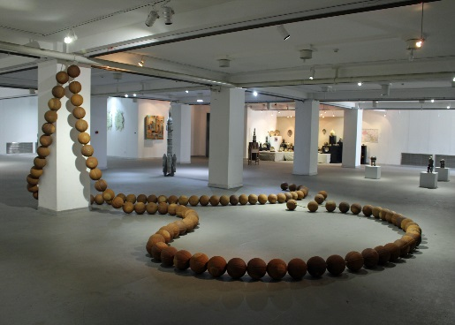  
Mathew Courtney

*Buddhist Basketball Beads*

© Matthew Courtney 2015  
  
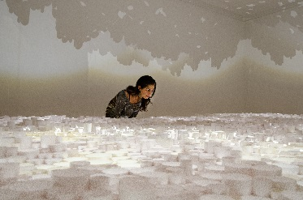  
  
Sun Young Kang

*In Between*

© Sun Young Kang 2014  
Photo by Caitlin Beattie  
*image can be cropped

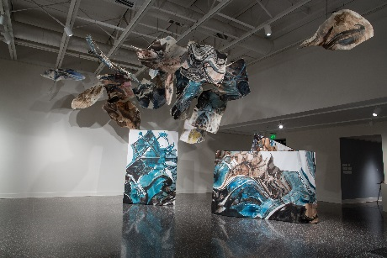  
Zahra Nazari

*Points of Departure Installation*

© Zahra Nazari 2014